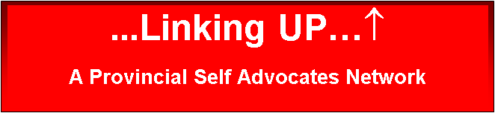
EVALUATION
- Are you enjoying the session? (Circle One)
 | NOT GOOD  I didn’t like it | PRETTY GOOD  It was okay | REALLY GOOD  I loved it!

- How was the communication? (Can you hear the speaker?)
NOT GOOD  I didn’t like it | PRETTY GOOD  It was okay | AWESOME!!  I loved it!

- Do you have any questions or comments you would like to share? (can be shared after the break or just within your group – if on LIVE Webcast, an email can be sent to linkingup@community-networks.ca
__________________________________________________________________________________________________________________________

- Have you heard of this topic before?
__________________________________________________________
- What did you like best?
__________________________________________________________

- What part would you “try” in your own life?
__________________________________________________________

- (Staff/site leader) Any thoughts or observations about the participants that you would like to share? (e.g. attendees laughed a lot, or showed emotion, or got excited, or frustrated or felt over-whelmed)

Please scan and email or fax back to …Linking UP…↑ at linkingup@community-networks.ca or 905-562-4621 attention Linking UP

