VOICES UNLIMITED OF HALDIMAND- NORFOLK PRESENTS:
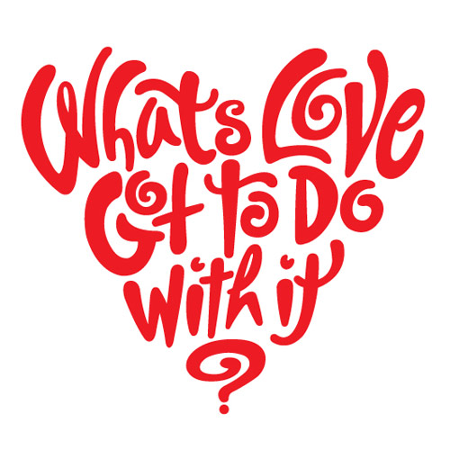
SAVE THE DATE!!!
Date: Friday, June 1st 2018 Time: 9:30- 5pm
Featuring w/shops on dating in today’s world and feeling confident in your sexuality. A speed dating session will end our day. Keynote speaker is consultant Ruth Fisher from Race4Romance.
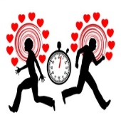
Dunnville, Ontario
$15 per person
For ages 18+
More information and registration coming April 2018
A workshop for people supported and their support workers
Disclaimer:
Graphic and sensitive information will be presented, discussed and provided so please provide supports accordingly.

