

Toolkit for Searching for Research Information

C:\Users\ptomlinson\AppData\Local\Microsoft\Windows\Temporary Internet Files\Content.IE5\A06E3QUH\MC900391682[1].wmf

Acknowledgments

This Toolkit was made possible by the Community Networks of Specialized Care Central Region. Thank you to their Research, Education and Evaluation Committee (REEC) who identified this Toolkit as a priority. In particular, thank you to the specific members who gave significant time to contribute to the initial concept, planning, development and review:

Barry Isaacs, Ph. D, Surrey Place Centre

Bill Gapen, BA MSW, Griffin Centre, George Brown College

Bill Sullivan, Dr., Surrey Place Centre

Brenda Quinlan, Community Living Association for South Simcoe, Georgian College

Christa Outhwaite-Salmon, Centre for Behaviour Health Sciences/ MacKenzie Health

David Hingsburger, Vita Community Services

Georgia Quartaro PhD, George Brown College

Jo Anne Nugent, EdD, Humber College

Karen Chartier, Lake Ridge Community Support Services

Katina English, Surrey Place Centre

Megan Primeau, MSc, Central Region Community Network of Specialized Care

Stephanie Cali, CAMH

Tanya Makela, MA.,BCBA, Lake Ridge Community Support Services

Yona Lunksy Ph.D., C. Psych., Centre for Addiction and Mental Health

Thanks also to the target audience representatives and additional committee members who spent time reviewing drafts of the Toolkit and providing feedback, ensuring the Toolkit was as user-friendly and practical as possible, including:

Ali Shahrami, C. Psych., BCBA, Centre for Addiction and Mental Health

Kris Braiden, Lake Ridge Community Support Services

And finally, thank you to Agnieszka Gorgon (BMus, MLIS; [agnieszkaigorgon@gmail.com](mailto:agnieszkaigorgon@gmail.com); [www.linkedin.com/in/agorgon](http://www.linkedin.com/in/agorgon); [www.twitter.com/libraraga](http://www.twitter.com/libraraga)), who completed the research, drafts and revisions of this document as guided by the REEC.

Table of Contents

**Section** Page

Introduction 1

Who Is It For? 1

How Does It Work? 1

Step 1: Before You Search 2

Key Points 2

Start With A Goal 2

General vs. Specific 2

Step 2: Choose Relevant Keywords 3

Key Points 3

Keywords 3

Synonyms, Acronyms and Related Terms 5

Spelling 6

Context: Consumer Vs. Professional 6

Step 3: Search (with Google) 7

Key Points 7

“Phrase Searching” 7

Boolean Operators 9

Google Advanced Search 9

Google Scholar 12

Additional Resources 13

Step 4a: Understand Your Google Results 14

Key Points: 14

Blogs 14

Websites 15

Academic Journal Articles 15

Encyclopedia Articles 16

Popular Magazine Articles 17

News Outlet Posts/Articles 18

Other Types Of Results 18

Additional Resources 18

Step 4b: Understand Your Google Scholar Results 19

Key Points: 19

Citations 19

Academic Journal Articles 19

Open Access Academic Journals 20

Subscription Based Academic Journals 21

Books 21

Other Types Of Results 21

Step 5: Evaluate for Quality 22

Key Points: 22

CRAAP: Currency 22

CRAAP: Relevance 22

CRAAP: Authority 23

CRAAP: Accuracy 23

CRAAP: Purpose 24

Examples 24

Additional Resources: 24

Step 6: Manage Your Findings 28

Key Points: 28

Browser Tools 28

Social Discovery Tools 28

Specialized Software 29

Conclusion 29

Introduction

**Disclaimer:** Please note that resources and examples used in this document represent areas of interest at a certain point in time. These are current issues people are wondering about, and hence were used to illustrate how to do an effective search about it. We recognize that with time information, websites, and search tools may become obsolete and/or the results of the searches will change.

Who Is It For?

**Anyone!**

Have you ever been asked by a client or a supervisor to identify reliable information online and you found Google a bit overwhelming?

This toolkit will help you streamline the search process. It has been created for anyone who has ever searched Google or Google Scholar and would like their searches to be more targeted and productive.

How Does It Work?

The six steps outlined below will introduce tricks and techniques that will save you time and, once put into practice, will lead you to reliable information.

**Step 1:** Before You Search

**Step 2:** Choose Relevant Keywords

**Step 3:** Search (with Google)

**Step 4a**: Understand Your Google Results

**Step 4B**: Understand Your Google Scholar Results

**Step 5:** Evaluate for Quality

**Step 6:** Manage Your Findings

Step 1: Before You Search

Key Points

1. Know what you are looking for before you start searching.
2. Ask yourself: *What do I want to find?*
3. Start with a general search and then make it more specific.

Start With A Goal

Before you start your search, have a clear idea of what it is you want to find. Choose keywords that will find the most relevant and useful resources. To do this, think about the ideal (or best) results you would like to find, and think of targeted or strong keywords. Identify the goal of your search by asking yourself: *“What do I want to find?”* Knowing exactly what you are looking for will save you time in the long run.

General vs. Specific

You may need to start with a general search to get an idea of what kind of information is available, and then make the search more specific. Let’s work through the following scenario:

*A client of yours is uncomfortable with vaccines. She read online that they cause autism. She asks for your professional opinion, and wants you to show her some reliable online resources.*

1. First, try a general search: for example, *vaccines autism* ([see search results](https://www.google.ca/search?q=vaccines+autism&ie=utf-8&oe=utf-8&channel=rcs&gws_rd=cr&ei=9SsuV6aGG8PMeJS1g_gP)).
2. To make this search more specific, you could add the word *children* to the search string: *vaccines autism children* ([see search results](https://www.google.ca/search?q=vaccines+autism+children&ie=utf-8&oe=utf-8&channel=rcs&gws_rd=cr&ei=QiwuV5-_LcjWeofdrLAI)).
3. Make this search even more detailed by looking for a specific vaccine, like MMR: *MMR vaccine autism* ([see search results](https://www.google.ca/search?q=vaccines+autism&ie=utf-8&oe=utf-8&channel=rcs&gws_rd=cr&ei=9SsuV6aGG8PMeJS1g_gP#q=MMR+vaccine+autism)).

You can see that three different searches result in three different sets of results. The general search had the highest number of results, while the third search had the fewest.

Knowing what you are looking for, before you start searching, will help you remove unwanted results and save you time.

Step 2: Choose Relevant Keywords

Key Points

1. Your search results will only be as good as the keywords you use.
2. Identify synonyms, acronyms and related terms, and use them in your search.
3. Consider different spelling options.
4. Use keywords in context.

Keywords

**Keywords** are words with a lot of meaning. When searching Google, keep your keywords to the point, and remember that less is more. Every time you use a different word, your search results will change. The keywords you use in a search have a direct connection to the information you find.

Take a look at the two search examples below. Compare the top 3 results. Look at the URL (web address – typically starts with [www.)](http://www.)). Are there any differences? (see next page)

|  |  |
| --- | --- |
|  |  |
| [Search 1](https://www.google.ca/search?q=do+vaccines+cause+autism&ie=utf-8&oe=utf-8&channel=rcs&gws_rd=cr&ei=3isuV6SAEYvOeJ3llfAJ#q=do+vaccines+cause+autism%3F): *do vaccines cause autism* | [Search 2](https://www.google.ca/search?q=vaccines+autism&ie=utf-8&oe=utf-8&channel=rcs&gws_rd=cr&ei=nTEuV56UCJDxevDYNw): *vaccines autism* |

Search 2, *vaccines autism,* is a better search than Search 1, *do vaccines cause autism*. Why? There are a number of words in Search 1 that are not needed, specifically *do* and *cause*. Every time you add a term to a Google search, the search algorithm looks for it and this affects the list of results.

Remember, with keywords – less is more.

Synonyms, Acronyms and Related Terms

**Synonyms** are words that have the same or similar meaning as the original keywords. For example, synonyms of the word *illness* are: *sickness*, *disorder*, *disease*, and *ailment*.

**Acronyms** and **Initialisms** are short forms of words.

* An **acronym** is an invented word, created from the initial letters of other words. For example: *ASAP*, which stands for as soon as possible.
* An **initialism** is a type of an acronym, which is pronounced one letter at a time. For example: *IBI* is an initialism for *Intensive Behavioural Intervention*.

Researchers often use acronyms and initialisms to describe a concept. To get a full scope of research on a topic, include both in your search.

**Related terms** are words that have almost the same meaning. Related terms for the word *illness* are: *affliction*, *indisposition*, *infection, virus*, *bug*.

Use synonyms, acronyms, and related terms in your search to help you find more relevant information. Different words are used to describe the same thing, and synonyms, acronyms, and related terms help capture a wider range of information.

A quick way to find synonyms and related terms is to use the *define* command in Google. Type: *define* (*your word here)*, for example: *define illness*. Here is an example of a [live Google search](https://www.google.ca/search?q=define+illness&ie=utf-8&oe=utf-8&channel=rcs&gws_rd=cr&ei=Hk4uV9vBFYumepH9s5gN#q=define+illness), and a visual representation (below).

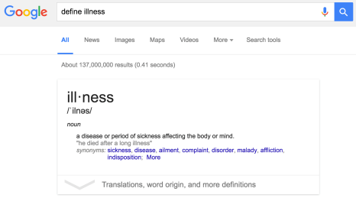

You can also find synonyms and related terms in a thesaurus. A few popular ones are:

1. [Merriam Webster Dictionary & Thesaurus](http://www.merriam-webster.com/)
2. [Thesaurus.com](http://www.thesaurus.com/)
3. [OneLook Reverse Dictionary](http://www.onelook.com/reverse-dictionary.shtml)

Spelling

When you search Google, you are searching for information on a global or international scale. Written English in Canada may not be the same as English in other parts of the word. For example, the Canadian/British spelling of *behaviour* is spelled *behavior* in American English*.* For more examples of spelling differences, take a look at this [Wikipedia page of potential spelling variants](https://en.wikipedia.org/wiki/Wikipedia:List_of_spelling_variants).

Context: Consumer Vs. Professional

There are many ways of describing the same thing. You saw an example of that in the Synonyms, Acronyms and Related Terms section. In addition, the health professional field has its own specialized language.

For example, keywords your client might use to find information on the topic of behavioural therapies for children with autism are: *what are behavioural therapies for children with autism* ([see search results](https://www.google.ca/search?q=autism+behaviour+therapy&rlz=1C5CHFA_enCA571CA571&oq=autism+behaviour+therapy&aqs=chrome..69i57j0l5.575j0j9&sourceid=chrome&ie=UTF-8#q=what+are+behavioural+therapies+for+children+with+autism)). Your search may look different because of your professional background: *intensive behavioural intervention autism* ([see search results](https://www.google.ca/search?q=intensive+behavioural+intervention&ie=utf-8&oe=utf-8&channel=rcs&gws_rd=cr&ei=21UuV4OZHML7e5qxi8AH#q=intensive+behavioural+intervention+autism)). Compare the number of results; see any differences?

The main difference between the above two searches is context based. Your client will most likely tap into consumer-type information, while you might find information that is more advanced. One is not better than the other – the difference is in the context of the search.

Step 3: Search (with Google)

Google Search, commonly known as Google, is a search engine that gives you access to information from around the world. There are a number of search strategies you can use to make your searches more powerful. You already saw an example of this with the command *define*.

Key Points

1. Use “phrase searching” to keep your search terms together.
2. Use Boolean Operators and take your search to the next level.
3. Use Google Advanced Search to build complex searches.
4. Use Google Scholar to find academic articles, conference proceedings and white papers.

“Phrase Searching”

**Phrase searching**, also known as quote searching, takes place when you put “quotation marks” around two or more words, in order to keep them together, as a phrase and in exactly the same order. Phrase searching helps find resources that contain exact words.

Quote searching gives you, the searcher, the ability to control the types of results Google finds. When you enter keywords without quotations, Google’s search algorithm searches for your terms as single keywords, different versions of your keywords, as well as phrase combinations, which leads to a large number of results.

When you search using a phrase, the number of results Google finds will be much lower, but those results will be specific to what you are trying to find.

Take a look at the two Google searches below, and compare the results:

|  |  |
| --- | --- |
|  |  |
| [Search 1](https://www.google.ca/search?q=depression+developmental+disability&ie=utf-8&oe=utf-8&channel=rcs&gws_rd=cr&ei=TV8uV9PqEYyEjwPW4afYDQ): *depression developmental disability* | [Search 2](https://www.google.ca/search?q=depression+%22developmental+disability%22&ie=utf-8&oe=utf-8&channel=rcs&gws_rd=cr&ei=D2AuV43BB9HCjwO0-buQBg): *depression “developmental disability”* |

Compare the number of results in Search 1 and 2. They are very different. Search 1 has 1,390,000 results, while search 2 has 226,000 results.

Search 2 is more targeted, because of the use of “phrase searching”.

Boolean Operators

Boolean operators are special search terms that can help you find more specific search results. The two most common Boolean operators are: **AND** and **OR** (always capitalized).

When you introduce Boolean operator **AND** to your search, you are asking the search engine (or a database) to find resources that include all the search terms you are looking for. Using Boolean operator AND will help you find fewer, but more specific, information sources. For example, the Google search “*mental illness” AND “psychological disorder”* finds results that contain both phrases, lowering the number of results.

*While you can use operator AND in Google, its search algorithm is set up for automatic AND. This operator is most commonly used when searching academic databases.*

Boolean operator **OR** helps to expand a search. OR = more. You can use OR to combine terms or phrases with similar meaning (synonyms and related terms). When you use OR, you will see the number of results increase. An example of a search using Boolean operator OR is: *“mental illness” OR “psychological disorder”.*

Here’s how introducing Boolean operators in a Google search affects the number of results:

1. [Search 1](https://www.google.ca/search?q=mental+illness+psychological+disorder&rlz=1C5CHFA_enCA571CA571&oq=mental+illness+psychological+disorder&aqs=chrome..69i57j0l2.307j0j9&sourceid=chrome&ie=UTF-8): *mental illness psychological disorder*

Number of results: 394,000

1. [Search 2](https://www.google.ca/search?q=mental+illness+psychological+disorder&rlz=1C5CHFA_enCA571CA571&oq=mental+illness+psychological+disorder&aqs=chrome..69i57j0l2.307j0j9&sourceid=chrome&ie=UTF-8#q=%22mental+illness%22+%22psychological+disorder%22): “mental illness” “psychological disorder”

Number of results: 133,000 (same number with use of AND)

1. [Search 3](https://www.google.ca/search?ei=q9z3WZLKPOfWjwT0148w&q=%E2%80%9Cmental+illness%E2%80%9D+OR+%E2%80%9Cpsychological+disorder%E2%80%9D&oq=%E2%80%9Cmental+illness%E2%80%9D+OR+%E2%80%9Cpsychological+disorder%E2%80%9D&gs_l=psy-ab.3..0i71k1l4.0.0.0.7158.0.0.0.0.0.0.0.0..0.0....0...1..64.psy-ab..0.0.0....0.edYTqfoAlWQ): “mental illness” OR “psychological disorder”

Number of results: 29,600,000!

OR = MORE

Google Advanced Search

**Google Advanced Search** is a guided, advanced search interface. The easiest way to find Advanced Search is to Google: *google advanced search*. Alternatively, you can find it from the main Google Search page, under Settings. [Here is the direct link](https://www.google.ca/advanced_search). (see image on next page)

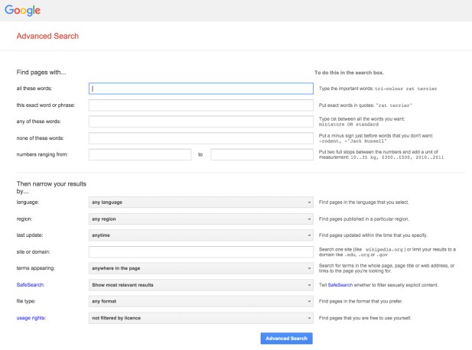

Google Advanced Search guides you through the process of putting together a very specific search and it also shows you how to do it in the regular search box (look at the text on the right-hand side).

Let’s take a look at building a comprehensive search, using Google Advanced Search.

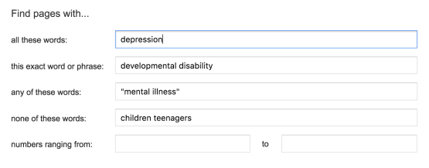

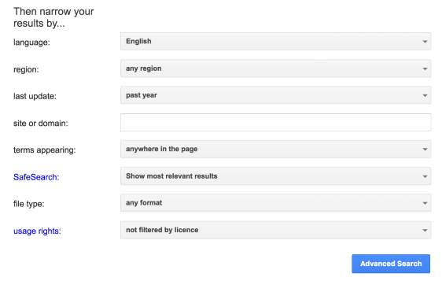

The above is an example of a complex search that targets results on the topic of depression (or mental illness) in adults (and not children or teenagers), written in English, in the past year (from 2015-2016).

Here’s what the above search looks like in the [Google Search](https://www.google.ca/search?hl=en&as_q=depression&as_epq=developmental+disability&as_oq=%22mental+illness%22&as_eq=children+teenagers+&as_nlo=&as_nhi=&lr=lang_en&cr=&as_qdr=y&as_sitesearch=&as_occt=any&safe=images&as_filetype=&as_rights=) box:



Google Scholar

By searching [Google Scholar](https://scholar.google.ca/), you will find articles published in academic journals, books and presentations. To learn more about Google Scholar, [access its About page](https://scholar.google.ca/intl/en/scholar/about.html).

You will only be able to access some of the journal articles you find through Google Scholar by paying a fee, while other content will be available free of charge (published in open source journals, a draft copy of the article, or a blog post).

There are 3 ways you can access paid content for free:

1. Through your local public library:

Public libraries typically have access to a limited number of academic databases (databases are platforms that store academic articles).

1. Through your professional association:

Professional associations sometimes provide access to various academic databases to their members.

1. Through a college/university library:

If you are affiliated with a higher educational institution, you will have access to a rich variety of academic databases through its library.

If you are pursuing a research project, Google Scholar is a great first step in identifying previously shared (published or posted) content on a number of different topics.

Let’s compare Google Search to a Google Scholar search, using the general search terms: *dual diagnosis schizophrenia*.

|  |  |
| --- | --- |
|  |  |
| [Google Search](https://www.google.ca/search?q=dual+diagnosis&ie=utf-8&oe=utf-8&channel=rcs&gws_rd=cr&ei=kHIuV8OFJ8PxepaCqLAK#q=dual+diagnosis+schizophrenia) results | [Google Scholar](https://scholar.google.ca/scholar?as_sdt=1,5&q=dual+diagnosis+schizophrenia&hl=en&as_vis=1) search results |

Additional Resources

1. [How to Search on Google](https://support.google.com/websearch/answer/134479)
2. Google’s [Search Education Online](http://www.powersearchingwithgoogle.com/) courses:
   1. *Power Searching*
   2. *Advanced Power Searching*
3. [Google a Day Challenges](https://www.google.com/intl/en-us/insidesearch/searcheducation/lessons.html#challenges)
4. [Power Searching with Google - Quick Reference](http://www.powersearchingwithgoogle.com/assets/misc/AdvancedPowerSearchingQuickReference.pdf) document

Step 4a: Understand Your Google Results

Tech entrepreneur Mitchell Kapor is quoted as saying: *“Getting information off the Internet is like taking a drink from a fire hydrant.”* Can you imagine drinking from a fire hydrant? Not the easiest task, but neither is searching. A single Google search will find millions of results in many different formats.

How do you know what you are looking at? Let’s take a look using the results of *vaccines autism* Google search as an example ([see live search](https://www.google.ca/search?q=vaccines+autism&rlz=1C5CHFA_enCA571CA571&oq=vaccines+autism&aqs=chrome..69i57j69i59l2j0l3.2361j0j4&sourceid=chrome&ie=UTF-8)). The examples below can be found on Page 1.

Key Points:

1. A typical Google search returns millions of results.
2. Search results come in many different formats: blogs, web pages, academic journals, popular and encyclopedia articles, and more.
3. Know what you are looking at before you trust the information.

Blogs

[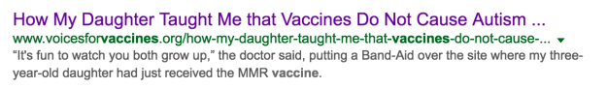](http://www.voicesforvaccines.org/how-my-daughter-taught-me-that-vaccines-do-not-cause-autism/)

Blogs are part of the social media family. They are updated on a regular basis and can be run by a person or an organization. Some blogs are part of a website. Blog posts (a post is a blog entry) typically invite comments from readers, and posts are organized in categories, as well as available through archives. Stand-alone blogs are very easy to create and maintain and can be used as a communication platform for anyone, from elementary school students and community groups to medical professionals.

Here are ways in which you can recognize a blog post:

1. Blogs are sometimes hosted on a free blogging platform. Wordpress and Blogger (blogspot) are the most popular ones. Because it is now easy to buy a customized URL (web address), many blogs have a URL that does not include *wordpress* or *blogspot* in it. Blogs hosted on a free platform have theme information at the bottom of the page (in the footer). For example: *Blog at WordPress.com | The Dyad Theme* ([see example](https://connect5conference.wordpress.com/)).
2. Blog posts typically have a post-publication date (time-stamped blog posts). This is linked to the blog archive system that groups blog posts by month/year of publication.
3. Content can be organized in categories (topics), and archived by date.
4. Blogs typically invite comments on posts, although it is easy to disable comments.
5. Blogs include social media sharing options.

The example above is a blog that is part of a website, run by a non-profit organization that is membership-based. This blog does not accept reader comments; they are disabled. Content is organized in Categories (topics), and Archives (posts by month of publication). A giveaway for it being a blog is the bolded **Blog** link in the top navigation. It looks like this blog was custom built and integrated as part of the website.

Websites

[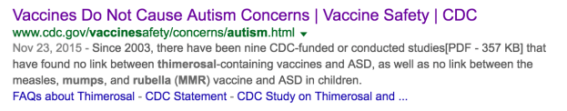](http://www.cdc.gov/vaccinesafety/concerns/autism.html)

[Dictionary.com](http://www.dictionary.com/browse/website) defines website as following:

*“A set of interconnected webpages, usually including a homepage, generally located on the same server, and prepared and maintained as a collection of information by a person, group, or organization.”*

This is a good definition. Websites are one of the types of information sources you will find online. Websites are typically more static, which means that information on them does not change too often (in comparison to blogs, where posts can be added daily, monthly, etc.).

The above is an example of a webpage that is part of a website. The website is run by the Centers for Disease Control and Prevention, and the page on Autism is part of the Vaccine Safety section. The website was developed by an organization that is linked to the US government. You can see this by looking at the beginning part of the URL (web address): <http://www.cdc.gov/>, .gov = government.

Academic Journal Articles

[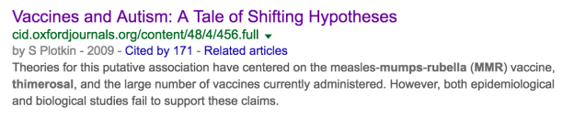](http://cid.oxfordjournals.org/content/48/4/456.full)

Academic journal articles are highly specialized, and use discipline specific words to talk about research. Some are peer-reviewed, looked at by subject specialists before publication to make sure information is valid and of interest to the professional community.

Until recently, all academic articles were published in subscription based journals. Subscription based means that the person who wants to read the article, has to pay for it. Databases paid for by libraries and/or professional organizations, house a number of academic journals.

A number of academic journals are now available online for free. The journals are referred to as open access journals, and they do not require payment for preview. In open access publications, the reader does not have to pay any fees in order to read articles published by the journal. This allows more people to have access to academic research.

The above example is an open access article, published in the *Clinical Infectious Diseases* journal.

Here is how you can recognize an academic article:

1. **Length**Academic articles tend to be long. They are usually text heavy and include tables, data and no illustrations.
2. **Language**Academic articles use language specific to the subject area. The language is very specialized and academic, and may not be easily understood by the general public.
3. **Authors**All academic journals clearly show who the authors are, listing their academic credentials and/or professional affiliations.
4. **Abstract**Every academic article has an abstract, which is a short description, or summary, of what the article is about.
5. **Sections**Academic articles are divided into clearly identified sections. Most have an *Introduction* and a *Conclusion*, with other section headings specific to information presented.
6. **Research and Data**Every academic article mentions other research done on the topic and shows data and figures specific to new research carried out by the authors.
7. **Citations and References**As you read through an academic article, you will see many in-text citations in the body of the article. These in-text citations link directly to the list of references at the end of the article. References tell you, the reader, where some of the information in the article came from, and give you access to more research on the topic.
8. **Appendices**Some academic articles include appendices (plural of appendix). An example of an appendix could be the survey tool used to collect information for the article, or a raw data set collected while doing research.

Encyclopedia Articles

**[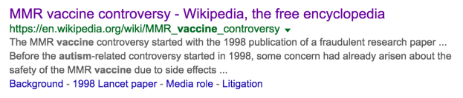](https://en.wikipedia.org/wiki/MMR_vaccine_controversy)**

Encyclopedia articles gather in-depth information on a topic. Facts are supported by research, found in the References section below the article and authors are not usually identified.

Wikipedia is the most popular open encyclopedia, freely available online. Information in Wikipedia articles is crowdsourced, which means that anyone can add or edit article content. This is both positive and negative. The positive side of crowd editing is wide coverage; the negative side is potentially erroneous (wrong) information. As with all encyclopedias, Wikipedia articles have references at the end of most articles. While Wikipedia is a good starting point, do not focus all of your research on these articles and do find other sources.

Popular Magazine Articles

**[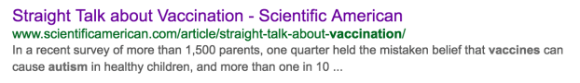](http://www.scientificamerican.com/article/straight-talk-about-vaccination/)**

Popular magazine articles have information on a wide variety of subjects presented in easy-to-understand language. Some have a subject focus (for example: Scientific American, Astronomy, Business Week, Time), but as a whole, popular magazines are written for consumers and not subject specialists. Language used in magazine articles is easier to understand by the general public, and while sometimes other research is included or linked to, this is not a requirement for publication.

When research articles or reports are included in popular magazine articles, anecdotes supporting the studies are included to engage the readers, providing everyday evidence to support findings of the study. Look beyond the anecdotes, and try to locate the source, or primary research.

The article in Scientific American shown above is an example of a popular magazine article. Written to add to conversations in popular media, consumer magazines reflect popular culture, interests and views of the general public.

Here are tools to help you spot a magazine article:

1. **Length**They are much shorter than academic articles.
2. **Language**They are written in language easy to understand by the general public.
3. **Photographs/illustrations**Full-colour images, photographs and illustrations are found in popular magazine articles.
4. **Author**The author’s/journalist’s name is sometimes included, but sometimes not. Online articles typically have the author’s name available.
5. **References**While some magazine articles link to studies and data in the body of the article, very few, if any, provide references.
6. **Comments**Online versions of magazines articles often include a Comments section. Comments sometimes provide more information on the topic, but most of the time reflect personal opinions of readers.

News Outlet Posts/Articles

**[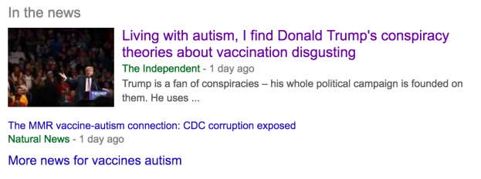](http://www.independent.co.uk/voices/donald-trump-autism-vaccination-link-conspiracy-living-with-autism-a7027676.html)**

You will often find newspaper articles and posts written by news outlets (like CNN, etc.) in your Google results. News articles reflect a community’s interests and share information as it happens. News articles can vary in length and some articles are opinion pieces. Comments are typically enabled and readers’ insights are visible.

Google displays news articles in a special *In the News* box, embedded in Page 1 of the results page, and also links to additional sources in the results list. Here is an example:

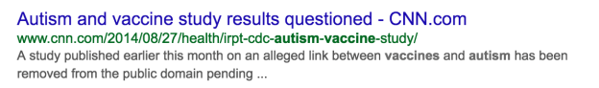

Other Types Of Results

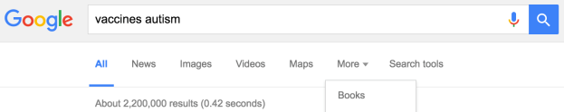

When you look at the Google results page, you will see other types of resources, specifically images, videos and books. A lot of good information can be found in non-text-based formats, like videos. Although sometimes Google will place the most relevant ones in the search results, remember that you can select to view specific resource types by clicking on the links directly under the search box.

Additional Resources

1. Know Your Sources: A Guide to Understanding Sources [www.pcc.edu/library/scripts/know-your-sources/index.html](http://www.pcc.edu/library/scripts/know-your-sources/index.html)

Step 4b: Understand Your Google Scholar Results

A Google Scholar search will find many different types of results. How do you know what you are looking at? Let’s take a look using the results of the following search: *vaccines autism*, as an example ([see live search](https://scholar.google.ca/scholar?hl=en&q=vaccines+autism&btnG=&as_sdt=1%2C5&as_sdtp=)). The examples below can be found on the first two pages of the Google results list.

Key Points:

1. Use Google Scholar when searching for academic information.
2. Google Scholar results are very different from those found searching Google.
3. Google Scholar finds articles published in academic journals – both subscription (paid) and open access (free), citations, as well as books, conference proceedings, white papers, theses and dissertations, patents, and more, published across a multidisciplinary landscape.

Citations

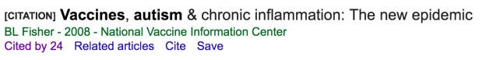

Citation is a bibliographic reference that gives you information about a publication. In a citation, you will find the following: title, author, date of publication and publication source (typically a journal).

When you find a [CITATION] in your Google Scholar results, it means that Google was unable to find the article online, but knows the article exists, as it has been mentioned in other academic publications.

If you find a citation that is very relevant to your search, you can use the information it has to search databases available in your public or academic library (if you have access to one), in order to find the full article.

Academic Journal Articles

Academic journal articles are highly specialized, and use discipline-specific words to talk about research. Some are peer-reviewed, which means that before the article is published, it is read and reviewed by subject specialists to make sure the information is valid and of interest to the professional community.

Here is how you can recognize an academic article:

1. **Length**Academic articles tend to be long. They are usually text-heavy, and include tables, data and no illustrations.
2. **Language**Academic articles use language specific to the subject area. This language is very specialized and academic and may not be easily understood by the general public.
3. **Authors**All academic journals clearly show who the authors are and their professional backgrounds.
4. **Abstract**Every academic article has an abstract, which is a short description, or summary, of what the article is about.
5. **Sections**Academic articles are divided into clearly identified sections. Most have an *Introduction* and a *Conclusion*, with other section headings specific to information presented.
6. **Research and Data**Every academic article mentions other research done on the topic and shows data and figures specific to new research carried out by the authors.
7. **Citations and References**As you read through an academic article, you will see many in-text citations in the body of the article. These in-text citations link directly to the list of references at the end of the article. References tell you, the reader, where some of the information in the article came from, and give you access to more research on the topic.
8. **Appendices**Some academic articles include appendices (plural of appendix). An example of an appendix could be the survey tool used to collect information for the article, or a raw data set collected while doing research.

Open Access Academic Journals

**[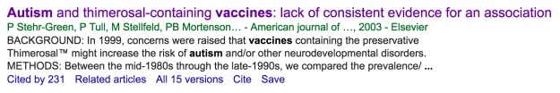](http://www.ajpmonline.org/article/S0749-3797(03)00113-2/fulltext)**

Open access journals are free to access, which means you will be able to read the article right away. In open access publications the reader does not have to pay any fees in order to read articles published by the journal. This allows more people to have access to academic research.

Open access journals are published by well-established publishers, for example: Oxford University Press – [Oxford Open](http://www.oxfordjournals.org/en/oxford-open/index.html), Wiley – [Wiley Open Access](http://www.wileyopenaccess.com/view/index.html), as well as newly established open access publishers.

When working with an open access journal, double check its background (look at the About/About Us, For Authors, Subscription pages), to find out as much as you can about how the journal accepts new articles and what the peer-review process is, to ensure that the information you are reading is reliable.

You can also consult DOAJ, [Directory of Open Access Journals](https://doaj.org/), that indexes reliable open access journals. Note that this index does not list all open access publications. You can also [look at this checklist](http://www.aje.com/en/arc/8-ways-identify-questionable-open-access-journal/) to help identify questionable, or predatory open access journals.

Subscription Based Academic Journals

[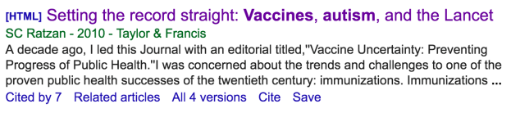](http://www.tandfonline.com/doi/full/10.1080/10810731003780714)

Google Scholar will also find articles published in subscription-based journals. Subscription requires someone to pay for access. Academic and public libraries, as well as some professional organizations and associations, have access to a selection of subscription-based academic journals through various databases (general databases such as Academic Search Premier, or more specialized ones such as CINAHL).

If you do not have access to any of the above, you can also purchase access to the article yourself. Pricing will depend on the level of access to the article (for example, temporary vs. permanent with unlimited download options).

Books

[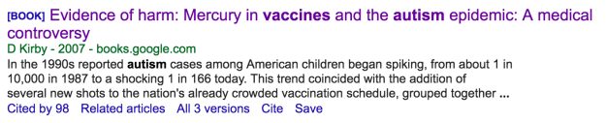](https://books.google.ca/books?hl=en&lr=&id=JlCS2A9WkuoC&oi=fnd&pg=PR11&dq=vaccines+autism&ots=0k5D_IjJcB&sig=LLlFxnwATwrOII__iTBxsJUYrpU#v=onepage&q=vaccines%20autism&f=false)

Google Scholar finds both fully digitized books, as well as books with partial content access. The above is an example of a fully digitized book, accessible online. When you open the book you will find your search terms highlighted, with digital “bookmarks” added throughout the scroll bar, linking you to pages that mention your keywords. This is convenient if you are quickly scanning through the book to see if it would be relevant.

Other Types Of Results

Your search will always dictate the type of information you find in Google Scholar. In addition to the above-mentioned, Google Scholar indexes the following types of resources from academic publishers, professional organizations, university digital archives and open-access content:

1. Conference proceedings
2. White papers
3. Pre-published material
4. Theses and Dissertations
5. Patents
6. Court opinions

For a full scope of School Scholar content coverage, refer to the [Content Coverage document](https://scholar.google.com/intl/en-US/scholar/help.html#coverage) developed by Google.

Step 5: Evaluate for Quality

Evaluation is the most important step in your research. You will always find information, regardless of how you search. The main goal is to see if the information you found can be trusted, if it is reliable.

To help you with this task, use the **CRAAP** **Evaluation Checklist**. CRAAP stands for: Currency, Relevance, Authority, Accuracy, and Purpose. It was developed to evaluate information found online (as opposed to academic research). You can use the CRAAP checklist when evaluating any piece of information, from tweets to online encyclopedia articles.

Key Points:

1. Always evaluate information you find.
2. CRAAP Evaluation Checklist is an evaluation tool to help you identify the best online results.
3. CRAAP is an acronym that stands for: Currency, Relevance, Authority, Accuracy and Purpose.

CRAAP: Currency

When checking for **currency**, look for the publication date of the information you are considering or when it was last updated. Answer the following questions:

1. When was the information published? (journal articles)
2. When was the content posted? (websites, blogs, online content)
3. Is the information up to date?
4. When was the content last updated?
5. Are links to internal and external pages working?
6. Does the information you are researching need the most recent publications? (Or can you use older publications as well?)

CRAAP: Relevance

**Relevance** considers the importance of the information you found, as related to your search. When checking for relevance, answer the following questions:

1. Is the information on exactly the topic you are researching?
2. Does the information answer your question?
3. Who was the content written for? Who is the “audience”?
4. Is the content written at an appropriate level?

For example, if you are working with a young client, can they read and understand the information or is it too academic? Alternatively, if you are doing your own research, is the information too simplistic?

CRAAP: Authority

**Authority** helps you find out who wrote or published what you are reading. Is the person an expert or are they a student blogger? The following questions will help you decide whether the information holds authority:

1. Who is the author?

Look for the person’s or organization’s name.

1. Can you find the author’s credentials and professional affiliation?

Is the author an employed medical practitioner or a concerned parent?

1. Is the author qualified to write about the topic?

Is the person who wrote the content an expert or an occasional blogger? Look for this information in the About section of a website/blog.

1. Is the author’s contact information available?
2. Look at the URL (web address of the website), and the domain name. Does it tell you something about the author?

.gov, .org, .com, .edu, .gc.ca (Government of Canada).

CRAAP: Accuracy

**Accuracy** targets the information’s reliability and correctness. Deciding if the information is accurate is a difficult task, as your opinions are subjective and potentially clouded by unconscious bias (bias you don’t think about). Ask the following questions when assessing accuracy of information:

1. Where does the information come from?
2. Are findings supported by evidence? Are there links in the website to the evidence, or do you have to search for it yourself?

Look for links to external sources throughout the page, or a list of references at the end of the paper/post.

1. Is enough information given about original research to make it replicable?
2. Can you access original data and findings that support the claims presented?
3. Can you verify the information in another resource/other resources?

Can you find additional content that shares the same information?

1. Is the information biased or one-sided?

Remember to check your own biases and preconceived ideas, as they may cloud your judgment.

1. Is the content grammatically correct?

Spelling mistakes are never a good sign.

CRAAP: Purpose

**Purpose** tries to find out why the information was created. Along with accuracy, it is one of the harder parts of the evaluation process. Answering the following questions should make it easier to identify purpose:

1. Why was the information published?

Is it educational, professional or personal?

1. Is the content based on facts supported by research or is it an opinion piece?
2. Is the information objective?

Once again, the point of bias can be looked at here. Is the information one-sided or are opposing viewpoints shared?

Examples

See table on the following pages for two examples reviewed using the **CRAAP** **Evaluation Checklist**.

Additional Resources:

1. Juanita College Library[CRAAP Test Worksheet](http://legacy.juniata.edu/services/library/instruction/handouts/craap_worksheet.pdf)

| CRAAP criteria | Blog Post – [source link](http://www.voicesforvaccines.org/how-my-daughter-taught-me-that-vaccines-do-not-cause-autism/) | Website – [source link](https://www.cdc.gov/vaccinesafety/concerns/autism.html) |
| --- | --- | --- |
| Currency | 1. Cannot find publication date on the blog post itself. 2. Cannot say if information is up-to-date, but it may be. 3. The website copyright © date is 2015 (found in page footer). 4. All links to external pages are working.   **FAIL** | 1. Page was last updated on Nov.23, 2015. Website itself updated in January 2017. 2. Content links to a number of studies, published between 1999-2014. 3. Links to internal pages are all working, some broken links to external pages.   **FAIL/PASS** |
| Relevance | 1. Information is about whether vaccines are linked to autism. 2. The content is a personal story, based on personal anecdotes. 3. It looks like the post was written for other parents and members of the Voices for Vaccines online parent-run non-profit. 4. The post is written in a conversational tone. This is a personal story.   **FAIL** | 1. Information focuses on debunking belief that vaccines are a cause of autism. 2. The content identifies, and links to, a number of scientific studies, reports, and articles. 3. Information included on this website is of interest to the general public. 4. The content has a professional tone like that of a report.   **PASS** |
| Authority | 1. The author is Juniper Russo, a freelance writer and a mother of 2. She is an advocate for science and evidence-based parenting. 2. Link to writer’s website is given. Links & Portfolio page gives some information about her previous work. 3. From the website, it looks like the author has done research on the topic of vaccinations and link to autism. She is not an expert on the topic, but knows a lot about it. The author has a daughter with autism. 4. Author’s contact information is available from her website, but not directly from the blog. 5. .org – the website/blog belongs to a non-profit organization.   **FAIL** | 1. The website is published by the Centers for Disease Control and Prevention and focuses on sharing scientifically proven data. 2. Information about the organization, including its Mission and Role, is available in the About CDC section. 3. CDC employs a variety of health professionals, whose investigative work is featured on the website. 4. Contact information for the CDC is available in the footer of each page. 5. .gov – this website falls under the government umbrella.   **PASS** |
| Accuracy | 1. The information is based on personal experience, supported by content from a variety of sources which supports the author’s story. 2. The author links to a number of external sources to support her personal story. 3. The information presented in the blog post is not scientific research, but a personal story; no data is provided. 4. Information seems to be one-sided – a pro-vaccines position. 5. The information can be verified elsewhere. 6. The grammar is correct; the tone is conversational.   **FAIL** | 1. The information is based on scientific evidence. 2. All claims are supported by reports and scientific research. 3. Related scientific articles are included below the article for additional reference on the topic. 4. Information is one-sided – it leans towards debunking the popular claim that autism is caused by vaccines. 5. Content on the page is grammatically correct.   **PASS** |
| Purpose | 1. The post is a personal story of a person who is a parent of a (vaccinated) daughter with autism. 2. The content is a personal story. 3. The content is one-sided.   **FAIL** | 1. The overall purpose of the website is to education the American public on a variety of topics of interest, presenting a scientific perspective. 2. Content is based on researched scientific evidence. 3. Information is one-sided. **PASS** |
| Comments | This was the first result (in June 2016) in the Google search: *vaccines autism*. Some would think the first result is always best, but not in this case. The post was on the topic of vaccines and autism, but it was a personal story of a parent. While personal experiences are valid, they cannot be duplicated or considered as scientific. This post was valuable in terms of lived experience, but did not have professional or expert merit. **FAIL** | This website was in the top 5 results, presented by Google, with *vaccines autism* search. While the information is one-sided, all claims are supported by numerous reports, scientific research, as well as additional links to pages of interest. Information on this page is meant for consumer readers.  **PASS** |

Step 6: Manage Your Findings

There are many tools that can help you organize information you find, from social web platforms and browser-based extensions, to specialized software applications. Everyone has a personal preference and you might be using a few tools to manage information already. Whatever the case, it is good practice to keep your personal and professional research organized. The tools below are organized by level of complexity, from easiest to use to the most complex.

Key Points:

1. Keep your information organized.
2. Use browser tools to bookmark pages.
3. Social discovery tools can help you keep information at your fingertips.
4. Specialized software can help you manage the process of research.

Browser Tools

Browsers, like Chrome, Firefox, Safari, allow you to store information as bookmarks and organize links in folders. For example, Chrome, a browser developed by Google, gives you access to all of your bookmarks from a number of different devices when you are logged in with your Google account.

Bookmarking is an easy way to keep all of your findings in one place.

Social Discovery Tools

Social bookmarking and productivity tools help organize information, as well as share it with others. Social discovery is the process through which people can find and connect with others, as well as share and find information. Social networking platforms like: [Facebook](https://www.facebook.com/), [Twitter](https://twitter.com/), [LinkedIn](https://www.linkedin.com/), promote online social interaction and content sharing, as do content discovery tools, such as [Pocket](https://getpocket.com/), [Feedly](https://feedly.com/), [Diigo](https://www.diigo.com/).

Benefits to using social tools to store your research are:

1. Research, store and retrieve on the go – available anywhere, anytime, from any device
2. Cloud storage – content does not take up room on your device and the information is always available
3. Social discovery and sharing – enable you to share your content and find sources others have shared

The disadvantages of using social tools to store your research are:

1. Cloud storage – your information sits on an external server; if the server goes down, access to your content is temporarily lost.
2. Dependence on wireless connection (Wi-Fi)/data plan – no internet connection equals no access to your information (unless there is an offline option).
3. Privacy concerns – storing sensitive research data online may not meet your privacy standards.

Here are some examples of social bookmarking and productivity/note taking tools. Keep in mind that there are hundreds of others and that the tools are always changing.

1. Bookmarking: [Diigo](https://www.diigo.com/), [Pocket](https://getpocket.com/)
2. Productivity: [Evernote](https://evernote.com/?var=2), [Microsoft OneNote](https://www.onenote.com/)

Specialized Software

If you are thinking of doing more in-depth research, consider keeping your information organized in specialized software, specifically a reference management tool. Reference managers help keep complete bibliographic information of an item, which is: title, author, publication source and date, etc., and some also allow for upload of the complete document (if applicable), and note taking. Two groups that use reference managers a lot are students (college and university) and researchers.

A few of the more popular reference management tools are [EndNote](http://endnote.com/), [RefWorks](https://www.refworks.com/refworks2/default.aspx?r=authentication::init), [Mendeley](https://www.mendeley.com/) (free), and [Zotero](https://www.zotero.org/) (free).

Conclusion

You have now worked through all six steps of the research cycle. As they say, *Practice makes perfect*, so put some of your newly learned skills into practice, and remember that critical evaluation is by far the most important research skill to master.