Rights And Responsibilities

**Rights**

**All people deserve to be treated equally and fairly.**

**The 9 Basic Rights**

1. **Right to engage in relationships**
2. **Right to be safe**
3. **Right to privacy**
4. **Right to say “No”**
5. **Right to make my own decisions**
6. **Right to be respected**
7. **Right to risk**
8. **Right to be healthy**
9. **Right to dream**

**Responsibilities**

**The things that people need to do to avoid failure.**

**Every right comes with a responsibility.**

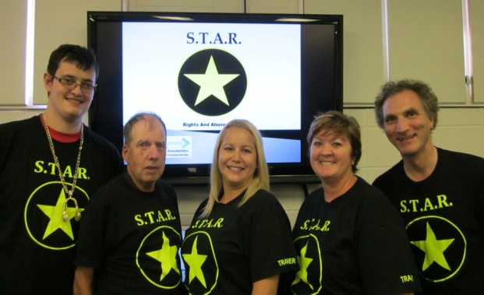

**For more information on S.T.A.R. contact:**

**Phone:**

905 835 8941 Ext 175 leave a message and your call will be returned

**Email:**

peoplehelpingpeople@clpcw.com



**S.T.A.R.**

**S.T.A.R.**



**S.T.A.R.**



RIGHTS AND ABUSE TRAINING

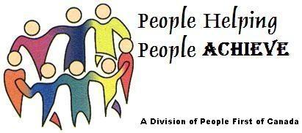

**What is Abuse?**

**To harm or h**

**urt someone**

**There are 5 types of Abuse**

**#1 VERBAL ABUSE** 

**#2 PHYSICAL ABUSE** MC900237922[1]

**#3 SEXUAL ABUSE** MC900197588[1]

**#4 FINANCIAL ABUSE** MC900196308[1]

**#5 NEGLECT** 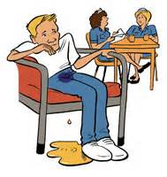

What Can I Do?

S.T.A.R.

**S**top

**Tell the person who is abusing you to ‘Stop’**

MC900384400[1]**T**hink

**Ask yourself…How can I protect myself? Who can I tell?**

MC900389176[1]**A**CT

**Get away from the abuser and find help**

MC900357027[1]**R**eport

**Tell someone you trust right away**

Who Can I tell?

MC900198594[1] MC900014777[1]

MC900280515[1] MC900357027[1]

MC900089562[1]

MC900365656[1] MC900310334[1]