If someone hurts me, or I am scared
Or afraid: - Safety Plan 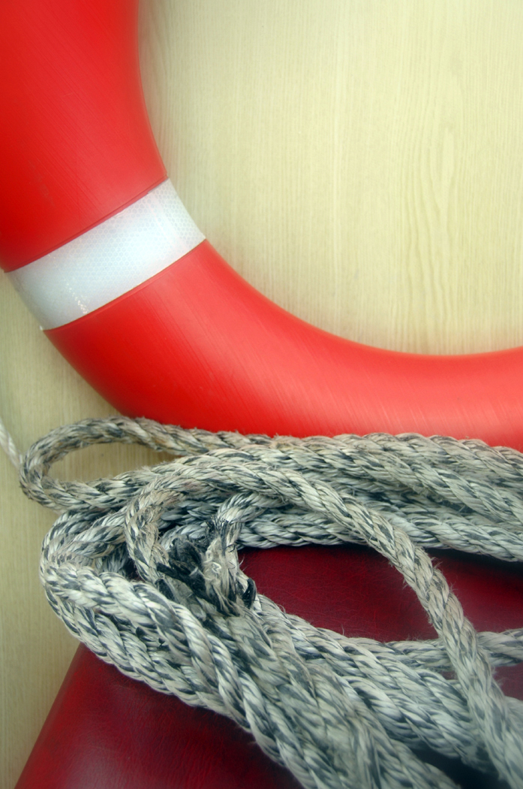
♦ I can yell “no” or “stop” very loudly.
♦ I can try to get away from the person who is
Hurting me.
♦ I can dial the police at 9 - 1 - 1.
♦ I can tell someone I like—someone I am not
Afraid of and feel comfortable talking about
Scary or uncomfortable things with.
♦ If the person I like and talk to cannot help, I
Can ask if they know someone else I can
Talk to.
♦ I can keep asking until I find help. It’s OK if I
Feel mad or sad if it takes time to find the
Right person to help.
♦ I can start to make a plan to feel safe.
♦ I can call
Name ________________
Phone ________________
♦Find friends, family members, faith community members, PA/caregivers, postal workers, delivery people, van drivers or others that can check on you regularly.
♦ Screen telephones calls by either an answering machine, caller identification, or assistance of another.
♦ Inform front line services of your special needs – can be flagged in computer

